2 COLOR STATE SEAL (blk

Version 1.0

February 11, 2020

by: Dina Heidar

State of Louisiana



IdentityServer4 Technical Design Document

TABLE OF CONTENTS

Revision History 3

Introduction 4

Purpose 4

Audience 4

Acronyms, Abbreviations, Terms and Definitions 4

Design Overview 5

Approach 5

Security Requirements 5

Architectural Goals and Constraints 5

Technologies Used 5

OpenID Connect and OAuth 2.0 Protocols Flows 6

What is IdentityServer? 7

Common IdentityServer Terminologies 8

User 8

Client 8

Token 8

Grant Types (Flows) 8

Resources 9

Scopes 9

Which OpenID Connect/OAuth 2.0 Flow is the right one? 9

Response Types 10

Proof of Concepts (POC’s) 11

Un-Authenticated User using Hybrid Flow and JWT as Client Assertion 12

Un-authenticated user using Authorization Code Flow and Proof Key for Code Exchnage (PKCE) 15

Topology Diagram 18

Features 18

Appendix A 19

References 21

**TABLE OF FIGURES**

Figure 1: OpenId Connect and OAuth 6

Figure 2 : Identity Server with External Identity Providers 7

Figure 3: Hybrid Flow with JWT as Client Assertion (Client Secret) 13

Figure 4: UML Sequence for Hybrid Flow with JWT Client Assertion 14

Figure 5: Authorization Code Flow and PKCE 16

Figure 6: UML Sequence for Authorization Code Flow with PKCE 17

## Revision History

| Version | Date | Description | Editor |
| --- | --- | --- | --- |
| **1.0** | 2/11/2020 | Initial Draft | Dina Heidar |

## Introduction

### Purpose

The purpose of this project is show how IdentityServer4 can:

1. Authenticate users via the clients to external non oidc/oauth Identity Providers (e.g. ADFS, CA IAM…. etc.) obtain in return an *access_token* to communicate with apis(e.g. SAML token to Bearer)
2. Eliminate the need for clients to create jwts for apis thus reducing responsibilities and update certificate maintenance issues when they expire (for both the clients and apis).
3. Create and verify jwts between clients and apis.
4. Obtain *access_tokens* and *id_tokens* without using *client_secrets*.
5. Obtain machine to machine *access_tokens* that contain the necessary client claims when actions are performed without users.
6. Have *access_tokens* contain the necessary user claims when api actions are performed on behalf of a user.
7. Ensure that *id_tokens* are either encrypted (JWE) or not exposed over the browser or both.
8. Add/remove/verify roles, claims and locations for users. (using identity and possibly AdminUI)
9. Utilize custom extension/ delegation grants. <https://www.scottbrady91.com/OAuth/Delegation-Patterns-for-OAuth-20>

### Audience

The intended audience for this document is State of Louisiana agency business technical architects and developers.

### Acronyms, Abbreviations, Terms and Definitions

Please refer to Appendix A for the list of all acronyms and abbreviations.

## Design Overview

### Approach

### Security Requirements

### Architectural Goals and Constraints

## Technologies Used

The target platform can be either Windows or Linux. The framework used is .NET Core 3.1 and the development environment is Microsoft Visual Studio.

## OpenID Connect and OAuth 2.0 Protocols Flows

OAuth (1.0/2.0) is a security standard where you sign in to an application using an existing account from another service and give that application permission/authorization to access your data or use features in another application on your behalf without giving it your password. OAuth has a number of “flows” (ways to log in and communicate with the app asking for permissions)

OpenID is another standard protocol for authenticating to external apps from a single account but focused only on authentication. This is the key difference with OAuth, where it was concerned on authorization, but it lacked the ability to authenticate users.

The OpenID Connect flow is an extension over OAuth with adds an additional layer to provide a mechanism to authenticate. It merges the latest OAuth and OpenID into a single system. It is basically a thin layer that sits on top of OAuth that adds login and profile information about the person who is logged in. ... The OpenID Connect flow looks the same as OAuth.

More info at <https://developer.okta.com/blog/2019/10/21/illustrated-guide-to-oauth-and-oidc>

**HTTP**

**OAuth 2.0**

**OpenID Connect**

Authorization

Authentication

Figure 1: OpenId Connect and OAuth

## What is IdentityServer?

Identity Server is an OpenID Connect provider - it implements the OpenID Connect and OAuth 2.0 protocols. The protocol flows are defined by setting a grant type(s) to clients. These grant types specify how a client can interact with the token service.

Identity Server has a number of jobs and features - including:

* protect your resources
* authenticate users using a local account store or via an external identity provider
* provide session management and single sign-on
* manage and authenticate clients
* issue identity and access tokens to clients
* validate tokens

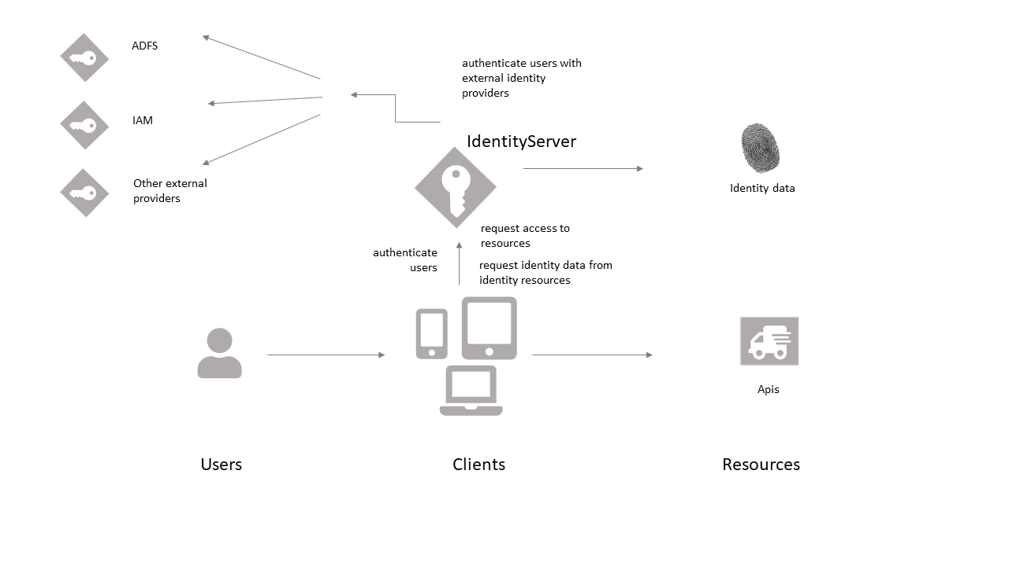

Figure 2 : Identity Server with External Identity Providers

## Common IdentityServer Terminologies

### User

A human that is using a registered client to access a resource

### Client

A client is a piece of software requesting a token from Identity Server e.g. Mobile app, web app, SPAs etc. Identity Server configures what type of tokens each client can request.

### Token

There are different types of tokens. Each token type has its own use. These tokens are requested from Identity Server by the client to use to access an API and/or to identity the user.

|  |  |
| --- | --- |
| **Token** | **Description** |
| *id_token* | for authenticating the user  identity token is the outcome of the authentication process  contains an identifier for the user (a sub/subject claim)  also contains info on how and when the user authenticated, but it can contain additional identity data which may represent user claims and more.  many OIDC implementers will use JSON Web Token as the format for this token but this is not part of the OIDC spec. JWT is also commonly used for access_token and refresh_token. |
| *access_token* | for accessing an API resource (authorize access to data). These are used as bearer token which means that the bearer can access the authorized resource without further authentication. They generally have a short lifespan.  clients request access tokens and forward them to APIs  contain information about the client and (optionally) the user which can be used to figure out how much they can do. This is how the APIs authorize. |
| *refresh_token* | these are used to obtain a new access_token. These are typically long lived. |

### Grant Types (Flows)

How a client wants to interact with Identity Server to retrieve an *access_token*. OpenID Connect and OAuth 2 defines a number of grant types:

1. ~~Implicit~~ - will not be covered here
2. Authorization Code
3. Hybrid
4. ~~Resource Owner Password~~ - will not be covered here since it is not recommended
5. Client Credentials

### Resources

These are what Identity Server protects, the identity data of the users and/or Apis. Every resource has a unique name - and clients use this name to specify to which resources they want to get access to. There are two types of resource categories:

1. **Identity Resources**: Identity information (aka claims) about a user, e.g. name or email address.
2. **Api Resources**: represent functionality a client wants to invoke - typically modelled as Web APIs, but not necessarily.

### Scopes

The access privileges/permissions that are being requested by the Client/Api. There are a number of built-in ones. Each scope has access to the certain user claims. Custom scopes can also be created.

|  |  |  |
| --- | --- | --- |
| **Type** | **Scope** | **Claims** |
| **OpenID Connect scopes (is an extension of OAuth2.0 scopes)** | *openid* | *sub, name, given_name, family_name, middle_name, nickname, preferred_username, profile, picture, website, email, email_verified, gender, birthdate, zoneinfo, locale, phone_number, phone_number_verified, address, updated_at* |
| **Standard OAuth2.0 scopes** | *profile* | *name, family_name, given_name, middle_name, nickname, preferred_username, profile, picture, website, gender, birthdate, zoneinfo, locale, updated_at* |
| *email* | *Email, email_verified* |
| *address* | *address* |
| *phone* | *phone_number, phone_number_verified* |

## Which OpenID Connect/OAuth 2.0 Flow is the right one?

**Machine to Machine Communication**: Client Credentials Flow

**Browser-based Applications (SPA)**: OAuth 2.0 working group now recommends Authorization Code with PKCE vs previously used Implicit.

**Native Applications**: Authorization Code with PKCE (with no secret since it is exposed in the GET request …it’s useless) 1 OR Hybrid with encrypted JWT 2 . In this document we will also present a third option (.NetCore 3.0) as a combination between the two, where the client secret is a JWE.

## Response Types

The different response types along with scopes tell Identity Server what information (types of tokens) to send to the client.3

|  |  |  |  |  |  |
| --- | --- | --- | --- | --- | --- |
| **Flow** | **Response Types** | **Scope** | **Authorization Code** | **Access Token** | **ID Token** |
| Authorization Code | Code | openid | **🗸** | **🗸** | **🗸** |
|  | **🗸** | **🗸** |  |
|  | Token | openid |  | **🗸** |  |
|  |  | **🗸** |  |
| Implicit | id_token |  |  |  | **🗸** |
| Implicit | id_token token |  |  | **🗸** | **🗸** |
| Hybrid | code id_token |  | **🗸** | **🗸** | **🗸** |
| Hybrid | code token | openid | **🗸** | **🗸** | **🗸** |
|  | **🗸** | **🗸** |  |
| Hybrid | code id_token token |  | **🗸** | **🗸** | **🗸** |
| Client Credentials | Code |  | **🗸** | **🗸** |  |

## Proof of Concepts (POC’s)

In this document we will POC 5 projects with Identity Server to address our current security, authentication and authorization issues.

These POC’s will not use Client Secrets since they present a security issue, the application cannot   
 securely store a Client Secret. Decompiling the application will reveal the Client Secret. The Client Secret is bound to the application and is the same for all users and devices.

Instead some of these POC’s will use a JWT (called a client assertion) instead of a client secret.

|  |  |  |
| --- | --- | --- |
| **Proof of Concept Project** | **Description** | **Framework Version** |
| MvcJwtClient.Web | Mvc Client w/JWE in a Hybrid Flow | .Net Core < 3.0 |
| MvcPkceClient.Web | Mvc Client w/PKCE in an Authorization Code Flow | .Net Core >3.0 |
|  | Mvc Client w/PKCE AND JWE in an Authorization Code Flow. | .Net Core >3.0 |
| MvcMtlsClient.Web | Mvc Client with MTLS. | .Net Core >3.0 |
| ConsoleJwtClient | Console app with JWT to represent a Gateway using Client Credentials (machine to machine) | .Net Core |
|  | Custom Delegation grants (Extension grants) to use from API to another API or to use with a machine to machine on behalf of a user. | .Net Core |

### Un-Authenticated User using Hybrid Flow and JWT as Client Assertion

This flow Is common however there are concerns with identity token (*id_token*) leakage (highlighted in figures) as it is exposed in the GET response. The recommended approach when using the hybrid flow is to use it in combination with encrypted identity token via is JSON Web Encryption (JWE).

The POC uses does implement encrypting the *id_token*

NOTE: In the IdentityServer world authorization code with PKCE now replaces OpenID Connect's (OIDC) hybrid flow as its most secure authorization method; however, not all client libraries or even OpenID Providers (ADFS???) support PKCE yet.

TODO:

Hybrid with JWT client assertion + JWE as id_token

Hyrbid as JWT client assertion + PKCE + JWE as id_token…. (overkill)?

Issues with JWE from ids4 with x5t

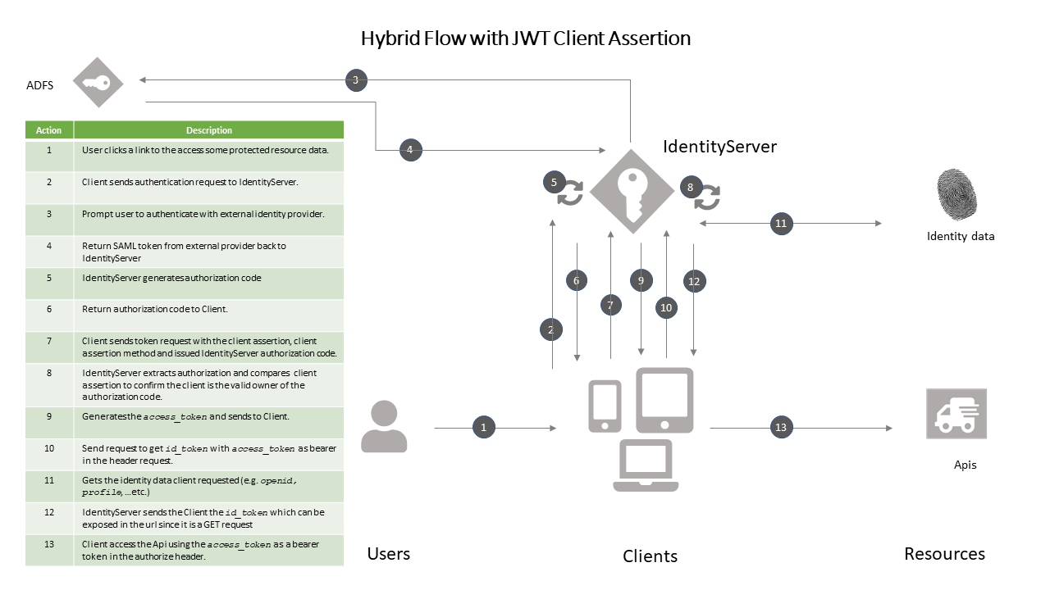

Figure 3: Hybrid Flow with JWT as Client Assertion (Client Secret)

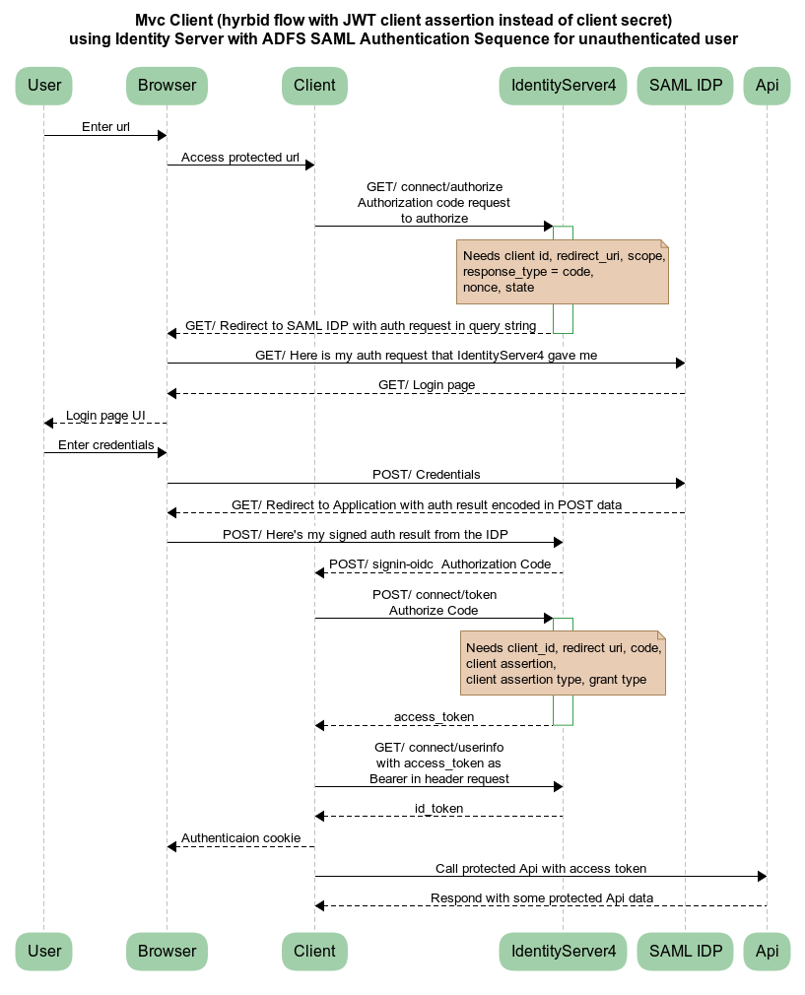

**Figure 4: UML Sequence for Hybrid Flow with JWT Client Assertion**

### Un-authenticated user using Authorization Code Flow and Proof Key for Code Exchnage (PKCE)

The PKCE-enhanced Authorization Code Flow introduces a secret created by the calling application that can be verified by the authorization server (IdentitySever); this secret is called the Code Verifier. Additionally, the calling app creates a transform value of the Code Verifier called the Code Challenge and sends this value over HTTPS to retrieve an Authorization Code. This way, a malicious attacker can only intercept the Authorization Code, and they cannot exchange it for a token without the Code Verifier

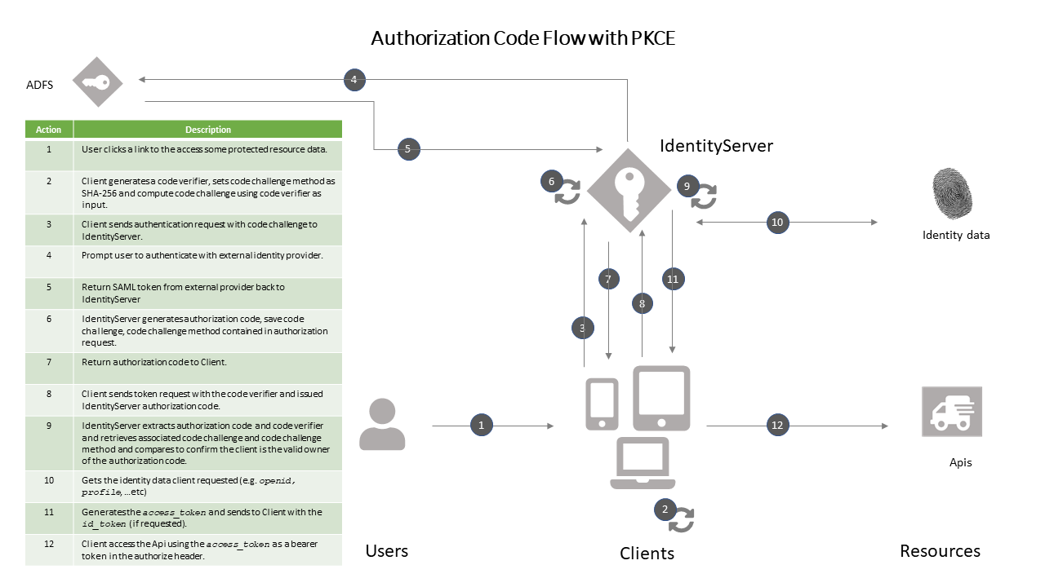

Figure 5: Authorization Code Flow and PKCE

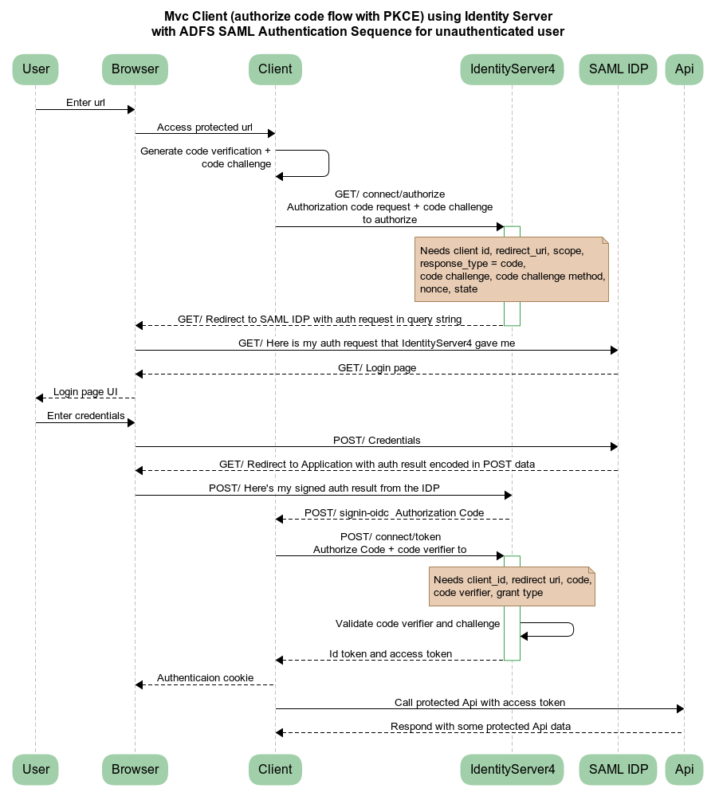

Figure 6: UML Sequence for Authorization Code Flow with PKCE

## Topology Diagram

## Features

## Appendix A

C

CEK: Content Encryption Key, 7

E

EA: Enterprise Architecture, 6

ESB: Enterprise Service Bus, 6

I

IAM: Identity Access Management, 6

IDP: Identity Provider, 6

J

JWE: JSON Web Encryption, 6

JWS: JSON Web Signature, 6

JWT: JSON Web Token, 6

O

OTS: Office of Technology Services, 7

S

SAML: Security Assertion Markup Language, 6

SOAP: Simple Object Access Protocol, 6

SSO: Single Sign-On, 6

*This page intentionally left blank*

## References

1. Brady S. ASP.NET Core using Proof Key for Code Exchange (PKCE). <https://www.scottbrady91.com/OpenID-Connect/ASPNET-Core-using-Proof-Key-for-Code-Exchange-PKCE>. Published 2019. Accessed2020.

2. Brady S. Encrypting Identity Tokens in IdentityServer4. <https://www.scottbrady91.com/Identity-Server/Encrypting-Identity-Tokens-in-IdentityServer4>. Published 2019. Accessed 2020.

3. Kawasaki T. Diagrams of All The OpenID Connect Flows. <https://medium.com/@darutk/diagrams-of-all-the-openid-connect-flows-6968e3990660>. Published 2017. Accessed 2/12/2020, 2020.